**Lab Sheet: Distributed Hadoop Application**

Task 1: Setting Up the Distributed Hadoop Cluster

Step 1: Prepare the Docker Compose File

Step 2: Deploy the Cluster

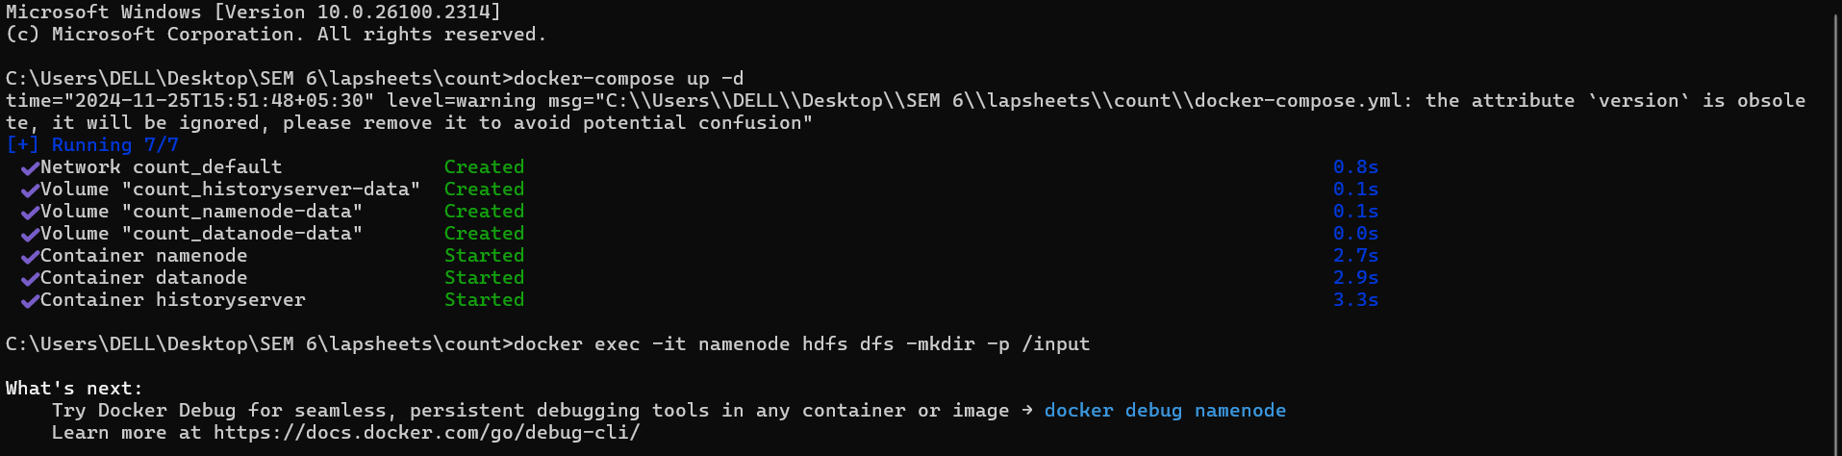

Step 3: Verify Cluster Status

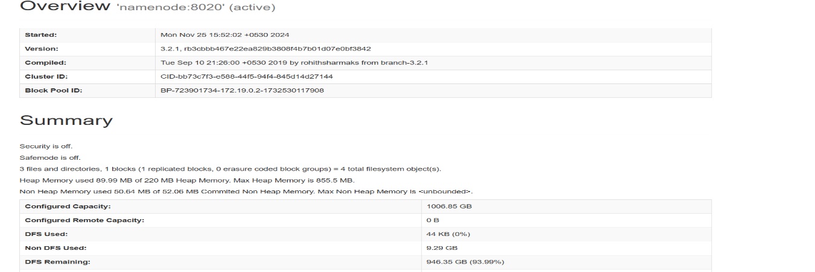

Task 2: Uploading Data to HDFS

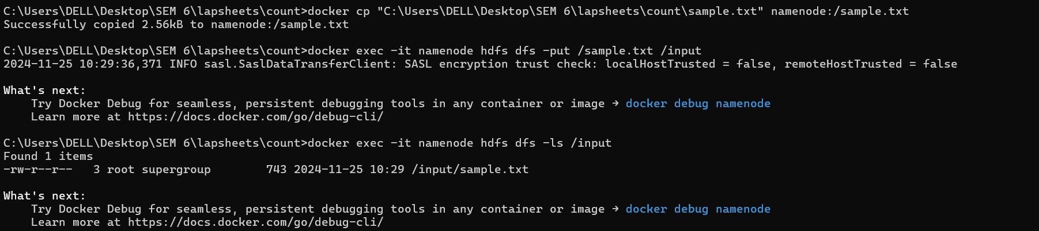

Task 3: Running a MapReduce Job

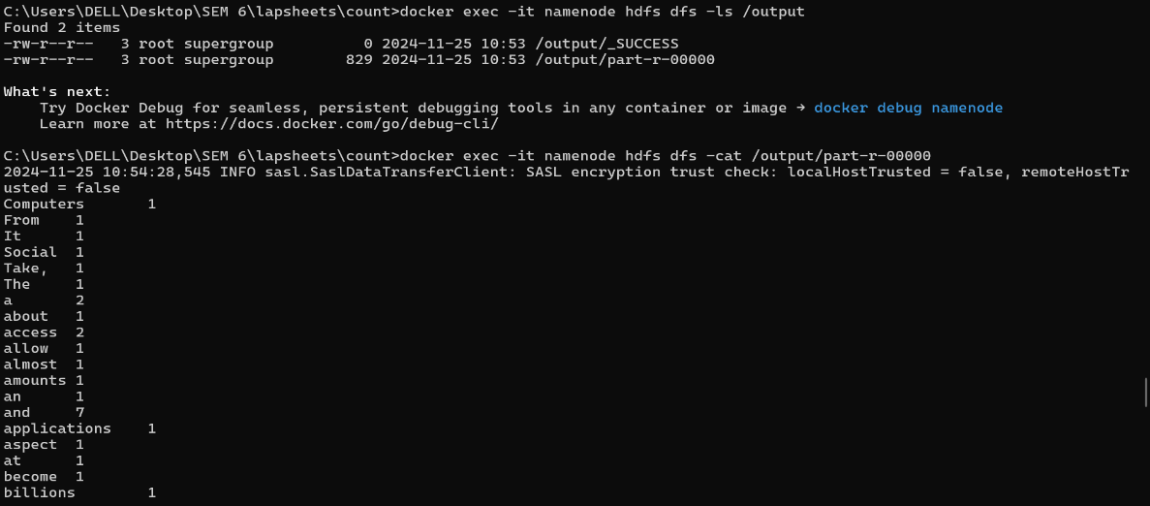

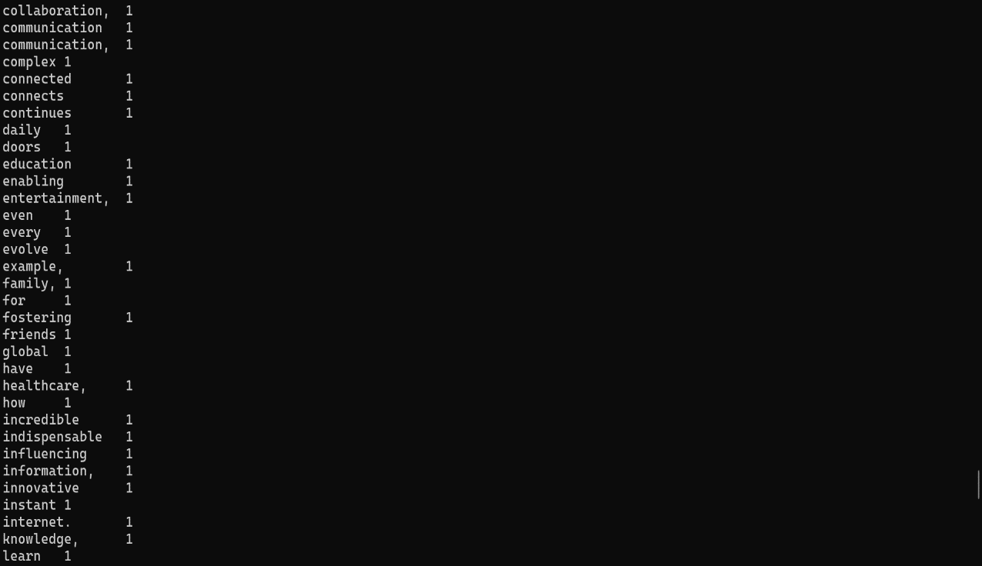

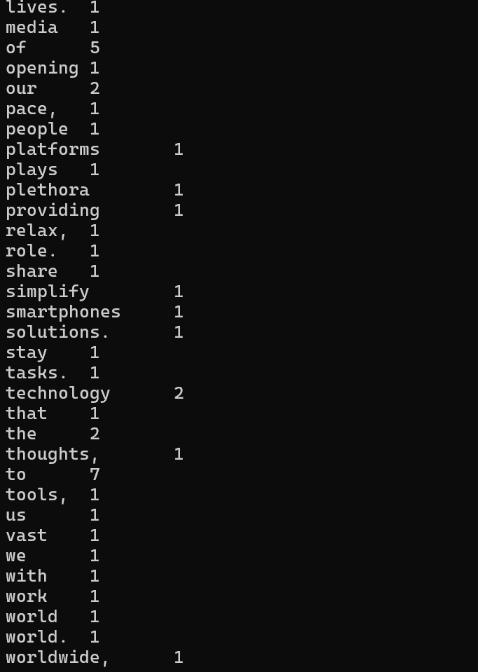

Task 4: Analyze and Clean Up

